Title: Blind Date
Year: 2018
Company: Goodman Theatre

Jan 20 – Feb 25, 2018 in Goodman's Albert Theatre
2 hours and 30 minutes including one intermission

The fate of the world depends on chemistry.
Before Twitter, Tinder and 24/7 news, two of history’s most enigmatic leaders—Ronald Reagan and Mikhail Gorbachev—meet to halt the arms race. A crafty game of one-upmanship ensues, while their wives engage in a passive-aggressive tango over tea. “A fresh and funny talent” (Backstage), playwright Rogelio Martinez “finds new twists on old topics” (Variety) in this compulsively fascinating, slyly comic backstage glimpse of a 20th century landmark event.
https://www.goodmantheatre.org/show/blind-date/
Blind Date
By Rogelio Martinez
Directed by Robert Falls
For a full version of the OnStage Program
for this Production please visit
GoodmanTheatre.org/LargePrint
Table of Contents
Page 2 — A NOTE from ROBERT FALLS, Artist Director
of the Goodman Theatre about Blind Date
Page 5 — Reagan, Gorbachev, and Me – A Conversation
with Playwright Rogelio Martinez written by Jonathan L.
Green
Page 11 — Blind Date Credits
Page 13 — Artist Profiles
2
A Note About Blind Date from Artistic Director Robert
Falls
In 1985, after decades of tension between the United
States and the Soviet Union, U.S. President Ronald
Reagan and Soviet General Secretary Mikhail Gorbachev
assembled for a meeting in Geneva, Switzerland. These
men, representing two of the world’s superpowers, sat in
cream-colored armchairs; once the photographers had
captured the occasion on film, only interpreters were
allowed to remain in the room. Meanwhile, Americans—at
least, those of us old enough in 1985 to pay attention to
world events—awaited news of how the Geneva Summit
transpired. This was, after all, a time before the 24/7 news
cycle and social media could deliver updates in real time.
Would the Soviet Union change now that a new leader
had taken office? Would Reagan accomplish his “mission
for peace?” Would the Cold War finally end? And the more
human questions: Would the two men even get along?
And if they did not warm to each other, what was at risk?
More than three decades later, with the answers to
those questions now printed in history books, I
encountered Rogelio Martinez’s provocative, absorbing
new play, Blind Date. The play unites arguably two of the
late 20th century’s most towering historical figures in ways
that reflect the mystery and significance of these events
3
when they first unfolded, yet allow us to keenly assess
them from a modern perspective. I was struck by the
play’s rigorous treatment of an historical moment—but
also by its humanization of its central characters, who like
many politicians, are sometimes rendered as distant
diplomats. And I appreciated its portrayal, too, of Nancy
Reagan and Raisa Gorbachev—political figures in their
own right who shaped the landscape of the 1980s in their
respective homelands.
In addition to my interest in the subject matter, I was
intrigued by the chance to work on a new play by this
remarkable playwright. Rogelio’s work has been produced
or workshopped by such distinguished companies as The
Public Theater in New York, the Denver Center for the
Performing Arts, the Oregon Shakespeare Festival and
Los Angeles’ Center Theatre Group, among others. Over
the past few years, he has written a series of plays that
deal with the Cold War era (learn more about these plays
on page 13) in which he turns his observant intellect and
biting sense of humor to subjects not necessarily primed
for laughs. We held several workshops of Blind Date over
the past year, allowing Rogelio to rewrite and rethink his
characters as a brilliant cast personified these public
figures. It has been my pleasure to direct those workshops
and the production you will see tonight.
4
I hope you will appreciate this play not only for its
thoughtful investigation of history (whether you remember
the era or not) but also for its witty and timeless
examination of human nature.
Robert Falls,
Artistic Director

https://www.youtube.com/watch?v=-Y8PmfoL3sw - Blind Date | Teaser

Before Twitter, Tinder and 24/7 news, two of history’s most enigmatic leaders—Ronald Reagan and Mikhail Gorbachev—meet to halt the arms race. A crafty game of one-upmanship ensues, while their wives engage in a passive-aggressive tango over tea. “A fresh and funny talent” (Backstage), playwright Rogelio Martinez “finds new twists on old topics” (Variety) in this compulsively fascinating, slyly comic backstage glimpse of a 20th century landmark event.
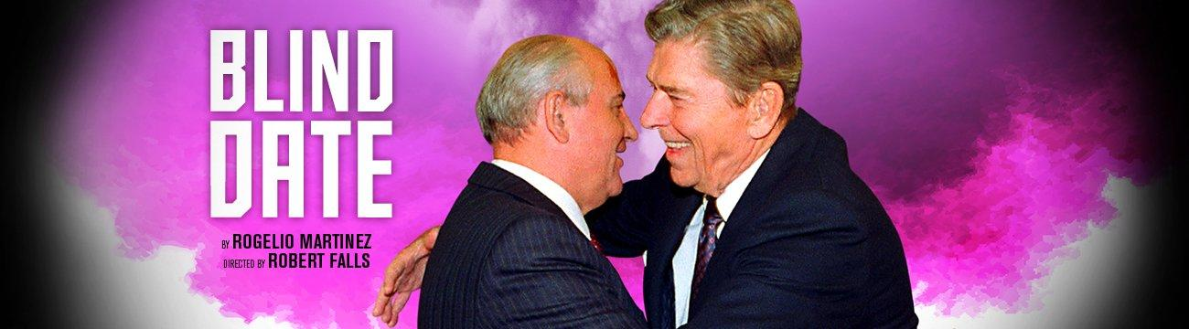
Heddy Weiss, Chicago Sun-Times
“Blind Date,” Rogelio Martinez’s playfully titled and altogether amusing geopolitical romp — now receiving a high-spirited Goodman Theatre premiere — might very well be described as a “Ron-com.” Ron as in Ronald Reagan, the actor, California governor and 40th President of the United States whose military and foreign policies some say helped bring the Cold War to an end (at least temporarily).
As with all blind dates, the “couple” — with Rob Riley as Reagan and William Dick as Gorbachev — arrive in a state of both apprehension and hopefulness. And their actual meeting (“truthy” as it might or might not be here, and without the presence of translators who are always essential elements in the room) is marked by all the nervous humor, misunderstandings, game-playing and awkwardness of such encounters.
The two men also arrive with their respective wives (Deanna Dunagan as Nancy Reagan and Mary Beth Fisher as Raisa Gorbachev, whose meeting over tea is one of the most irresistibly hilarious and brilliantly played scenes in To be sure, “Blind Date,” directed with great ingenuity by Robert Falls, is no documentary.
But the Cuban-born Martinez, who has riffed on the Cold War era in several other plays, captures both the personalities and issues in play, including the Reagan administration’s “Strategic Defense Initiative,” which raised the hackles of the Soviet Union, a nation already suffering from the fallout of its war in Afghanistan, a flailing economy, and Gorbachev’s untested leadership.
Two more wildly different personalities than “Ron” and “Misha” could not have been put in a room together. And yet, for whatever reasons (a mutual wish for a sane approach to major differences), they managed to find some common ground. And now, seen with the power of hindsight, a sort of melancholy overlays the farcical aspects of the play simply because we know Gorbachev’s short tenure ultimately led to the arrival of Vladimir Putin, that Reagan’s legacy was laced with a diagnosis of Alzheimer’s disease and that nuclear war is no longer a matter of just two sides.
https://splashmags.com/2018/02/blind-date-review-a-world-premiere-play-by-rogelio-martinez-at-the-goodman-theatre/
https://playbill.com/article/tony-winner-deanna-dunagan-rob-riley-and-more-tapped-for-the-goodmans-blind-date

https://stageandcinema.com/2018/01/30/blind-date-goodman/

https://www.broadwayworld.com/chicago/article/World-Premiere-of-BLIND-DATE-Comes-to-Goodman-Theatre-20180119

https://www.theatreinchicago.com/blind-date/9614/
https://www.newcitystage.com/2018/02/04/trivial-pursuit-a-review-of-blind-date-at-goodman-theatre/

https://www.chicagoonstage.com/blind-date-entertaining-history-lesson/

https://www.chicagotribune.com/2018/01/30/blind-date-is-an-intriguing-look-at-the-reagan-era-with-deanna-dunagan-as-a-perfect-nancy/

